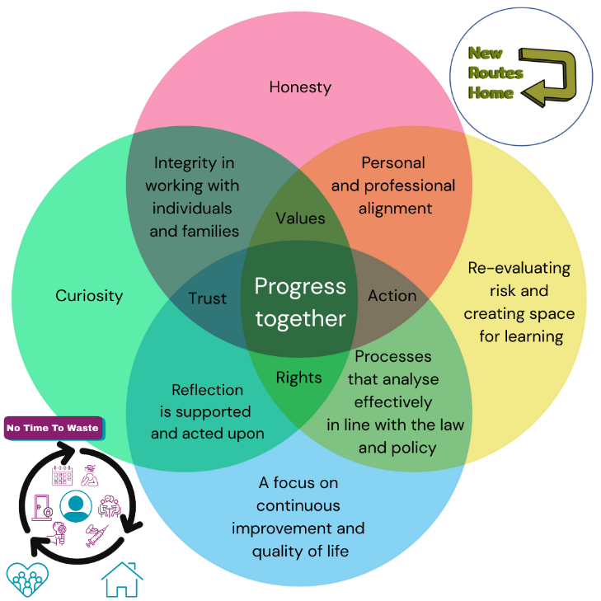
Making decisions together - using a reflective process

Give everyone the time to share and ask clarifying questions - explore the possible ways forward together. Don’t jump straight to actions.

What is most important to the person - how do we know?

Use Person Centred Planning, gather feedback from people who know the person well.

What do we feel we are getting right and why?

What are we concerned about and why?
How are building on what is going well?
What evidence is there that the person is managing the current plan?

What are the opportunities and risks -
- If we make no changes
- If we make changes that we think are better
Will the person see this as progress or something worrying?
Phrasing changes as positives - avoid the use of “no*
How can we make our actions predictable and based on the same principles, so the person doesn’t feel unsafe?
How do we build in clear steps that maximise choice and reduce the impact of any difficulties, giving a clear path back to positivity?

